- After receptionist clicks start session for any doctor - It says token 0 active – it should be token 1 active and whenever doctor clicks next – it moves one by one in the token display board.
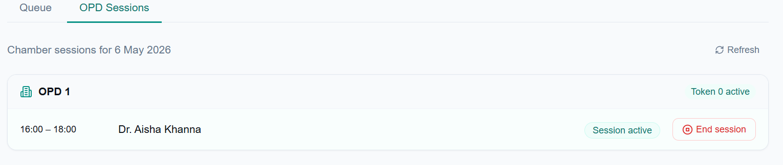
- In The appointment page – queue tab – the token number currently in display in token board must be marked as “with Doctor”. The example of the entire workflow is given below:
Receptionist clicks on “Start Session” for a doctor -> in the queue tab of appointment page, the patient having an appointment with that particular doctor with Token 1 is marked as “With doctor” automatically -> doctor finishes consultation and clicks next on his tab -> Token display board changes to Token 2 for that particular OPD and doctor and in the queue tab of appointment page, the patient having an appointment with that particular doctor with Token 2 is marked as “With doctor” automatically – and this goes on till the last appointment booked for that day with the doctor -> Receptionist clicks “End Session” after doctor leaves the OPD chamber
- The doctor while consulting a patient will have two options – either to write a digital prescription or to write a physical prescription. Below is the description of the OPD consultation page that the doctor will be seeing:
The OPD page will show all the appointments of that particular doctor on that day – with only the current patient (who is with the doctor) row having the “write digital prescription” button activated. At the bottom of the OPD page there will be a big “next” button – which upon clicking changes the token number in the display board and in the OPD consultation page, “write digital prescription” button gets activated for the patient having the next token number – and it goes on till the last patient appointment for that particular doctor
- If a doctor chooses to write a physical prescription – then the doctor won’t be clicking on the “Write digital prescription” button against that patient appointment. Once the consultation is over – the doctor clicks next and the above workflow continues. In this case the system should detect that a digital prescription has not been written and hence alternatively a physical prescription has been written and a button of upload prescription comes next to that particular patient in the appointments queue page. Below is an example of the workflow:
Example 1 – Physical Prescription Workflow:
Receptionist clicks on “Start Session” for a doctor -> in the queue tab of appointment page, the patient having an appointment with that particular doctor with Token 1 is marked as “With doctor” automatically -> doctor finishes consultation without clicking on the “write digital prescription” button and clicks next on his tab -> The receptionist can see a button “Upload prescription” against that patient appointment in the appointment queue page -> the patient comes out and the receptionist asks him for his prescription -> the patient hands over the physical prescription to the receptionist -> receptionist clicks on “upload prescription” button for that particular appointment -> switches on the scanner and scans the document and the scanned prescription gets stored in that particular patient profile -> the appointment gets marked as “completed”.
Example 2 – Digital Prescription Workflow:
Receptionist clicks on “Start Session” for a doctor -> in the queue tab of appointment page, the patient having an appointment with that particular doctor with Token 1 is marked as “With doctor” automatically -> doctor clicks on “write digital prescription” and clicks on save prescription -> the doctor lands back to the OPD page and the prescription gets saved in that particular patient profile -> doctor clicks on “next” button -> the token display board changes to the next token number. In this scenario, the receptionist will see the appointment for this particular patient automatically marked as “completed” as the digital prescription gets automatically saved.

